DIS-Ebay-2015 Nov 9

Sold by [acuervo22](http://myworld.ebay.com/acuervo22) ( [223](http://feedback.ebay.com/ws/eBayISAPI.dll?ViewFeedback&userid=acuervo22) )

### Delivery package 1 of 1

Estimated delivery Thursday, Nov 12, 2015 - Monday, Nov 16, 2015

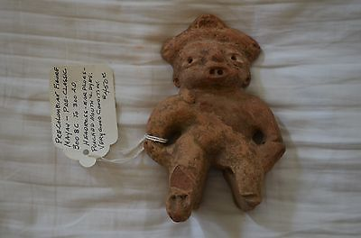

#### [Mayan Figural Sculpture, Pre-Classic Era 300 BC - 300 AD, Pre-Columbian](http://www.ebay.com/itm/151878374917)

|  |  |
| --- | --- |
| Item price | $109.99 |
| Quantity | 1 |
| Item number | 151878374917 |
| Shipping service | USPS Priority Mail |